Circadian rhythm

You may have heard of Circadian Rhythm which means reoccurring rhythm of biological processes. We have a natural internal clock that responds to lightness, darkness and timing of sleep.
Chinese Medicine have a 24 hour body clock that is divided into 12 lots of 2 hours of energy (vital force) which moves through the organ system. Have a look at the body clock to see which time you regularly wake up in the night and see which organ this corresponds too. 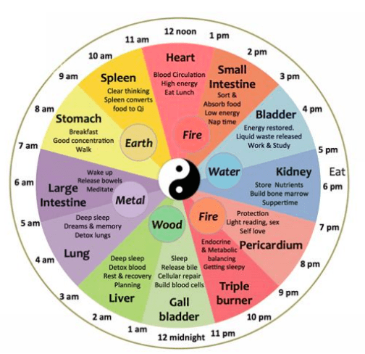
Between the hours of 11pm and midnight , the process of cells renewing is at it’s peak, which is why the saying “I must get my beauty sleep” could almost make sense! Going to bed at or before 11pm is when our cells repair and replenish through stem cell .
Whilst we sleep our cells are repairing, renewing and multiplying to support our immune system, hormones and metabolism. We naturally produce Melatonin our sleep hormone as it gets dark. By regulating our sleeping habits, this informs our pineal gland to secrete melatonin around 2 hours before we go to bed. Sleeping in a dark environment and not having too many bright lights switched on in the house, will prompt the pineal gland to produce more melatonin, ready for a peaceful night’s sleep.
Melatonin naturally stops producing as the sun rises and light sets in. Melatonin is also a powerful antioxidant being researched for antiaging and its anti-inflammatory effects.
Vitamin D is essential to produce melatonin and getting out in day light will help absorb more vitamin D to enable a robust production of melatonin ready for sleep. To a lesser extent, melatonin is produced in the retina in the eye, which is why walking in morning daylight is an excellent way to aid better sleep.

Going to sleep regularly, repetitively before 11pm has been shown to improve:
- Immune response
- Regeneration of bones and cartilage
- Digestion and absorption
- Skin and tissue regeneration
- Blood glucose management
- Weight loss
- Altering gene expression
- Regulating body temperature
- Regulated stress hormone cortisol.
- Increase Energy through mitochondria support.

Working with our natural circadian rhythm and regulating bedtimes will help regulate blood glucose and therefore metabolism and weight management. Insulin which is our hormone that regulates glucose is more sensitive in the day, than in the evening, which makes sense to reduce fast releasing carbohydrates at night. Swap these for complex carbohydrates including quinoa, wholemeal rice, root vegetables and pulses.
Regulating blood glucose alone leads to lowered risk of cardio vascular disease, dementia, elevated cholesterol and a strong anti-aging strategy.

.

